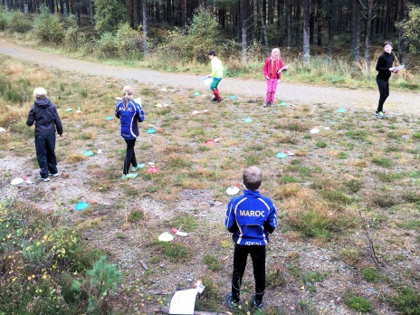
Mar Orienteering Club
Easter Holiday
Orienteering Camp
Tues 11th , Wed 12th , Thu 13th Apr 2017
10:00-12:30
Orienteering is an exciting outdoor adventure sport which involves navigating around a course using a detailed map and sometimes a compass. The aim is to navigate in sequence between a set of control points and decide the best route to complete the course in the quickest time.

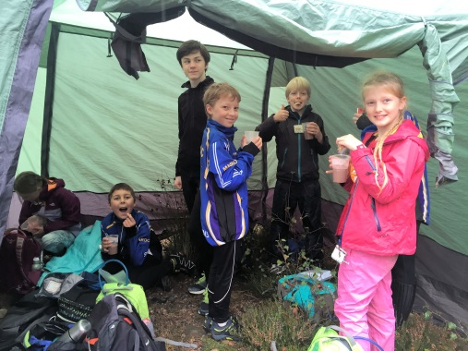
We will once again hold a 3-day holiday camp this April based in mid Deeside forests. The camp will be suitable for anyone age 9+ and we will offer orienteering training from beginner level up to “light green” colour standard. The camp will be led by orienteering coaches Sarah Dunn and Jon Musgrave.
11th Apr: Shooting Greens, by Potarch
12th Apr: Dess Woods (Deeside Activity Park)
13th Apr: Pannanich, Ballater
Fees £10 per session / £25 for all 3 days
Please complete the attached application form to register or contact Sarah Dunn dessdunn@gmail.com Tel. 013398 84447 if you require any further information about the camp.
This summer Deeside will host a major international week-long family orienteering festival

Attendance at the Holiday Camp and a couple of follow-on events will equip you with the skills needed to participate in Royal Deeside 2017

More details at https://www.scottish6days.com/2017

Application Form
To reserve your place, please fill in the form below and return by e-mail to Sarah Dunn: dessdunn@gmail.com
Please bring a signed copy with payment (cash or cheque made payable to Sarah Dunn) to the first session.

Participants Name: ……………………………………………………………..
Date of Birth: …………………………………………….
Dates for attendance: Tues 11th Wed 12th Thu 13th (delete as applicable)
Name of Parent / Guardian: …………………………………………………...
Home Address: ………………………………………………………………….
Email: …………………….………………………………………………………
Tel No:1: ……………………………… 2:…………………………………….

Names and contact details of two adults in case of emergency.
Name 1:……………………………………………………………………..Contact No:………………………
Name 2:……………………………………………………………………..Contact No:………………………

Medical Information:
Recent Surgery for…………………………………..… Date:………………...
Please give details of any medical condition, medication, allergies, or any other relevant information which we should know about:
……………………………………………………………………………………..........................................................
Please state any restrictions you wish to be placed on emergency medical treatment ………………………………………………………………………………………………………………………………………..….
Family Doctor ………………………………………………………... Tel ……………………………..

I agree to photos being taken of my son/daughter which may then be used for publicity purposes YES/NO (delete as applicable)

Parent’s Signature ………………………………………………………………. Date ……………………………………

