Final Details Maroc Local event

at Creag Choinnich (Braemar)

Sunday 8th November 2020

Location:
- Post code AB35 5YH, grid reference NO 152915
- what3words: thrusters.headings.searched

General:
- This event is only open to members of MAROC, GRAMP or AUOC due to Covid-19 considerations.
- Fees for orienteering club members: £5 for adults and £2.50 for juniors, students and adults on Yellow. Payment will be by email invoice.
- Accompanying persons will not be charged.
- Entries are now closed. No entry on the day.

Directions and Parking:
- Signposted from the A93 North Deeside Road
- Please use the car park behind the former Invercauld Arms Hotel and don’t block access to any properties.
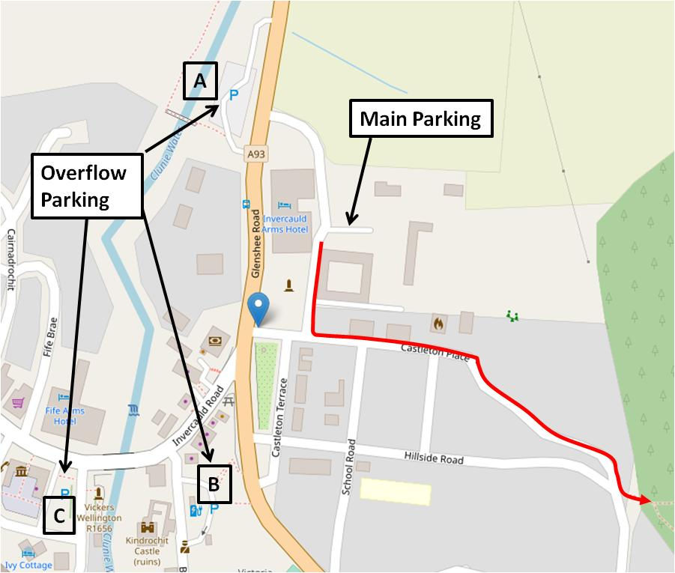
- In the event that the parking is full, please use one of the public car parks in Braemar, shown on the map.
- The route to the Start will be signed from the Car Park. It is approximately 500m from the main parking to the Start all along quite back roads or forest paths. It takes about 6 minutes to walk. Young children walking this route should be accompanied at all times. Please walk on the left.

Registration and Start Times:

- Start times have been pre-assigned. A Start list will be posted on the Maroc website, no later than Friday, 6th November.
- Due to a good turn-out, the Start window has been extended to run from 11:45 until 13:00. If you have been assigned a Start time before 12:00, and think that you cannot get there in time, then please contact the Organiser.
- Hired SI cards can be collected from the Download tent which will be on the way to the Start.
- Starts: 11:45-13:00
- Please do not arrive at the Start any earlier than 7 minutes before your Start time.
- Courses close at 15:00. You must report to Download even if you haven’t visited all the controls (safety check).

Course Information:
- Blue: 5.6 km with 300m climb
- Green: 4.2 km with 130m climb
- Light Green: 3.1 km with 165m climb
- Yellow: 2.0 km with 60m climb

Maps
Maps for all courses are to be picked-up after you have started. The control descriptions are printed on the maps but if you wish to print out your own loose descriptions a pdf copy will be available on the event website.

SPORTident timing
- SI Electronic punching is in use but SIair will NOT be enabled.
- Please note that a lost hire SI-Card will be charged for at a rate of £30, unless the Club Commitee agrees that there are special circumstances.
Facilities
Nearest toilets are in the public car park in Braemar, marked B on the map above.

Safety
A comprehensive risk assessment has been carried out by the organiser, but participants take part at their own risk and are responsible for their own safety during the event.
Weather:
We hope for good weather for November, but in the event of extreme weather conditions, it may be made compulsory to wear a cagoule. Cancellation due to extreme weather is a possibility.

Covid:
Subject to Scottish Government COVID rules in operation on the day of the event, as well as Scottish Orienteering’s COVID rules.
A Covid Risk Assessment will be completed for the event.
All participants need to take note of the following important information:
- If you're displaying one or more Covid-19 symptoms you must not attend.
- If you are in Covid-19 quarantine you must not attend.
- People in higher risk categories as set out by the government should be aware that attending could put you at increased risk.
- The 2 metre rule applies at all times, including at controls, so please move away from controls as soon as you have punched and wait if someone else is at the control when you arrive.
- Please give way to other non-orienteering members of the public, including walkers and cyclists.
- Please keep young children with you at all times.
- Please do not congregate at the start, finish, download or car park. The officlal British Orienteering guidance is to go directly from the finish (download) to your transport, and to leave the event once all members of the party have returned.
- By taking part you agree to British Orienteering’s code of conduct

Other things that will be different from our previous local events:
- Please use the hand sanitiser provided at the start and at the finish
- No splits printout will be issued on finishing – results will go online soon after the event.
- Please avoid touching the controls.
- Avoid unnecessary contact with fences and gates/stiles (you may still have to climb them and/or go through them).
- We won’t have a communal car key drop box.

Ticks and Lyme Disease:

Ticks are abundant in Deeside forests, and some will still be present, even in November. A small proportion of those ticks are infected with Borrelia bacteria that cause Lyme Disease. To protect yourself try to avoid tick bites as much as possible. It is advisable to use insect repellent before your run, and to wear leggings that extend down to the ankle. For maximum protection wear orienteering gaiters. After your run, remove clothing promptly, shower and check for ticks, removing any that are embedded in the skin with a tick remover tool or tweezers. An infection of Lyme borreliosis would be indicated by a rash that expands to form rings - this may develop 3-30 days after the tick bite, and you should contact your GP immediately if you develop this. Not everybody gets a rash, and you should also contact your GP if you experience any of the following symptoms; flu-like symptoms, fatigue, headaches, migratory muscle and joint pain, nausea, stiff neck.

Officials:
- Organiser & Covid Officer: Trevor Ricketts
- Asst Organiser: Fran Getliff
- Planner: Denise Wright

