Community Orienteering and Protection of the Environment
Orienteering Club
Tuesdays 3:30 – 4:30pm
7th, 14th, 21st, 28th March 2017
Meeting at Ballater School

Orienteering is an exciting outdoor adventure sport which involves navigating around a course using a detailed map and sometimes a compass. The aim is to navigate in sequence between a set of control points and decide the best route to complete the course in the quickest time.
This summer Ballater will host a major week long orienteering event: “Royal Deeside 2017 Scottish 6 Days”. The after-school club will teach the basic techniques involved in orienteering, with the aim that children who have attended the after-school club sessions will be able to participate in the 6-Day event this summer.
The sessions are suitable for complete beginners in P5-7 and will be led by Level 3 orienteering coach, Sarah Dunn. We will meet at the school and then usually walk in to Craigendarroch woods for the session.
Further information on the Scottish 6 Days can be found here:
http://www.scottish6days.com/2017
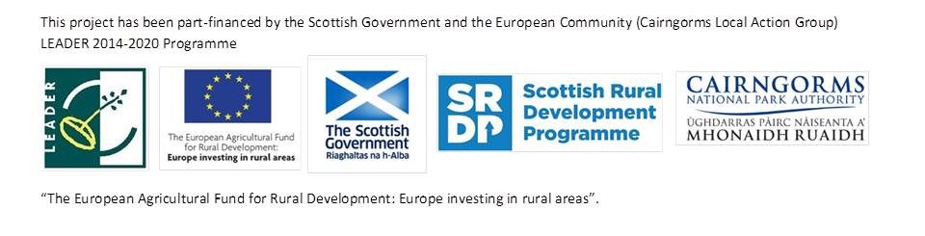
Application Form
To reserve your place, please fill in the form below and return by e-mail to Active Schools Co-ordinator Shona Park: shona.park@aberdeenshire.gov.uk
Please return form by 27th Feb at the latest
Please bring a signed copy to the first session.
Participants Name: ……………………………………………………………..
Date of Birth: …………………………………………….

Name of Parent / Guardian: …………………………………………………...
Home Address: ………………………………………………………………….
Email: …………………….………………………………………………………
Tel No:1: ……………………………… 2:…………………………………….

Names and contact details of two adults in case of emergency.
Name 1:……………………………………..Contact No:………………………
Name 2:……………………………………..Contact No:………………………

Medical Information:
Recent Surgery for…………………………………..… Date:………………...

Please give details of any medical condition, medication, allergies, or any other relevant information which we should know about ……………………………………………………………………………………....

Please state any restrictions you wish to be placed on emergency medical treatment ……………………………………………………………….
Family Doctor ……………………………….. Tel ……………………………..

I agree to photos being taken of my son/daughter which may then be used for publicity purposes YES/NO (delete as applicable)

